Contents

1. Introduction 1

1.1 Purpose 1

1.2 Document Conventions 1

1.3 Project Scope 1

1.4 References 1

2. Overall Description 1

2.1 Product Perspective 1

2.2 User Classes and Their Use Cases 1

2.2.1 Visitor 1

2.2.2 Customer 2

2.2.3 Seller 2

2.2.4 Administrator 2

2.3 Operating Environment 2

2.4 Design and Implementation Constraints 2

2.5 Assumptions and Dependencies 3

2.6 Business rules 3

3. Functional Requirements 4

3.1 System Functional Overview 4

**3.2 Search & Filter Product** 10

**3.3 Interact with map** 11

**3.4** **View Product Detail** 11

**3.5** **Change Amount** 12

**3.6** **Delete Product** 13

**3.7** **Delete Cart** 13

**3.8** **Login** 14

**3.9** **Register** 15

**3.10** **Send Code** 16

**3.11** **View User List** 17

**3.12** **Edit User** 18

**3.13** **Delete User** 19

**3.14** **Add Ship Information** 20

**3.15** **Change Ship Information** 21

**3.16** **Reset Password** 21

**3.17** **Change Password** 23

**3.18** **User Profile** 24

**3.19** **My Orders** 25

**3.20** **Order Information** 25

**3.21** **View Product List** 26

**3.22** **Sale Dashboard** 27

**3.16** **Order List** 29

Function trigger: Admin Login and click Total Invoices 29

Function description: 29

• Role: Admin 29

• Purpose: Admin views list of all of 2orders 29

Screen layout: 29

**3.17** **Order Details** 29

**3.18** **View Feedback** 30

**3.19** **Send Feedback** 31

**3.20** **Blogs List** 31

**3.21** **Blog Details** 32

**3.22** **View Notifications** 33

• Screen layout: 34

**3.23** **View All Notifications** 34

• Screen layout: 35

**3.24** **Mark as read** 35

• Screen layout: 35

**3.25** **Search to Compare** 35

• Screen layout: 36

**3.26** **View Comparison** 36

**3.27** **Error** 37

• Screen layout: 37

4. Data Requirements 38

4.1 Logical Data Model 38

4.2 Data Dictionary 39

4.3 Reports 42

4.3.1 Ordered Product History Report 42

4.4 Data Integrity, Retention, and Disposal 43

5. External Interface Requirements 43

5.1 User Interfaces 43

5.2 Software Interfaces 43

5.3 Hardware Interfaces 44

5.4 Communications Interfaces 44

6. Nonfunctional Requirements 44

6.1 Performance Requirements 44

6.2 Security 45

6.3 Availability 45

7. Other Requirements 45

# Introduction

## Purpose

This document describes the requirements for eracomputer.com website, which provides services and supplies electronic devices for purchaser. Types of reader this document is intended for: developers, project managers, testers, etc.

## Document Conventions

The functional requirements for this project are organized by use case within user class.

## Project Scope

eracomputer.com is a standalone website that provides common electronic devices for the customers. This website will permit purchasers to pick up electronic devices from the company online to be delivered to specified locations.

## References

Existing web sites used as models for ideas regarding the functionality documented and user interface style here include:

* <https://www.hanoicomputer.vn/>
* <https://shopee.vn/>
* <https://fptshop.com.vn/>
* <https://tiki.vn/cua-hang/tiki-trading>
* <https://www.pinterest.com/>

# Overall Description

## Product Perspective

Eracomputer.com is a new software system which improves the shopping quality of buyers with the biggest perk is convenience. This website was built to make a place where people can come to find and discover any electronic devices they might want to buy online.

## User Classes and Their Use Cases

### Visitor

A visitor is someone who visit the eracomputer.com website to learn more information about electronic devices sold on this website. Use cases:

UC-V-1: View all products

UC-V-2: Search for a product

UC-V-3: View product’s detail

UC-V-4: Read blog

### Customer

A customer is someone who orders a product from the eracomputer.com website. Use cases:

UC-C-1: Login

UC-C-2: View all products

UC-C-3: Search for a product

UC-C-4: View product’s detail

UC-C-5: Add product to cart

UC-C-6: Checkout

UC-C-7: Check order status

UC-C-8: Cancel order

UC-C-9: Rate product

UC-C-10: Give feedback

UC-C-11: Read blog

### Seller

A seller is someone who has the responsibilities to manage the website’s products and the business important data

UC-S-1: Create a product

UC-S-2: Modify a product

UC-S-3: Delete a product

UC-S-4: Add promotion detail

UC-S-5: View dashboard

### Administrator

An administrator is the person who has the responsibility to manage users of eracomputer.com website. Use cases:

UC-A-1: Change users’ information

UC-A-2: Delete an user

## Operating Environment

The eracomputer.com website shall be compatible with standard web browsers on Windows, Mac, and Web-enabled smart phone platforms.

## Design and Implementation Constraints

CO-1: The administrator shall be able to maintain and modify the site without requiring any specialized technical knowledge.

CO-2: The backend web must be written in Java programming language.

CO-3: All HTML code shall conform to the HTML 5.0 standard

## Assumptions and Dependencies

Assumptions:

* External libraries are always available

Dependencies:

* User’s environment (Browser)
* External libraries

## Business rules

|  |  |  |  |  |
| --- | --- | --- | --- | --- |
| ID | Rule definition | Type of rule | Static or dynamic | Source |
| BR-1 | Deliveries must be completed in 1 week after the order approved | Constraint | Dynamic | Shop policy |
| BR-2 | All goods in a single order must be paid for by using the same payment method. | Constraint | Static | Shop manager |
| BR-3 | Only sellers can create, modify, or delete products. | Constraint | Static | Shop manager |
| BR-4 | Only administrators can modify, or delete users. | Constraint | Static | Shop manager |
| BR-5 | Order price is calculated as the sum of each order item price times the quantity of that order item ordered, plus shipping fee | Computation | Dynamic | Shop manager |

## 3. Functional Requirements

### 3.1 System Functional Overview

#### a. Screen Flow

User

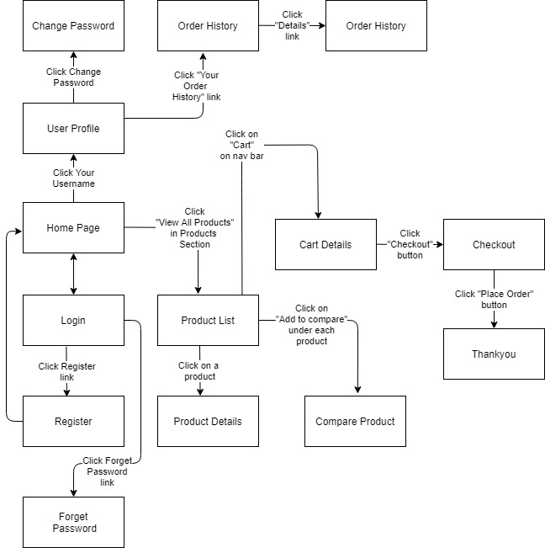

Figure 1-1: Screen Flow for User

Admin

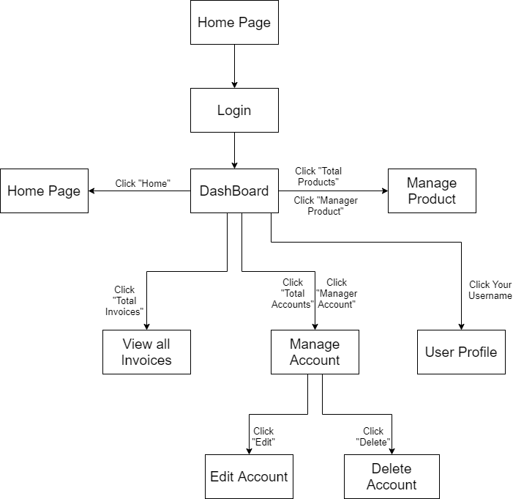

Figure 1-2: Screen Flow for Admin

Seller

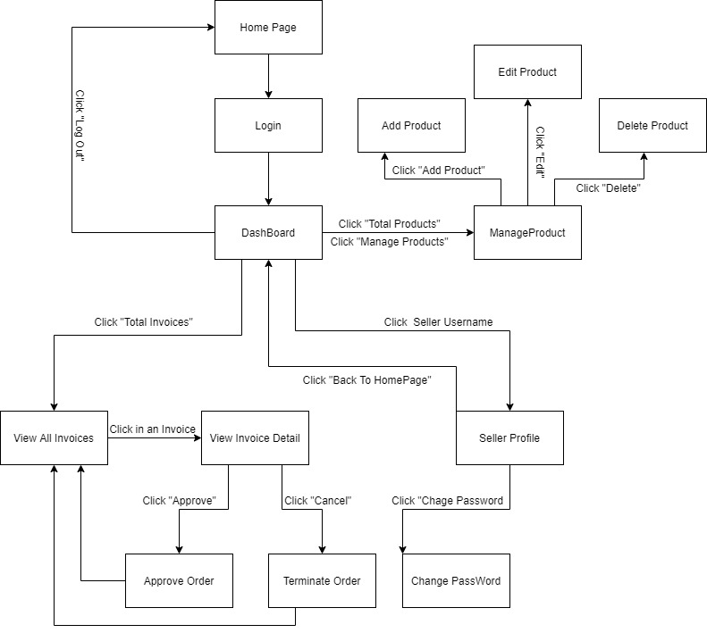

Figure 1-3: Screen Flow for Seller

#### b. Screen Details

|  |  |  |  |
| --- | --- | --- | --- |
| **#** | **Feature** | **Screen** | **Description** |
|  | Search & Filter Product | Home Page | Search for a Product by name or filter it by category |
|  | Interact with map | Home Page | Use the map to find the location of the shop |
|  | View Product Detail | Product Details | Display detail information of Product |
|  | Change Amount | Cart Details | Plus or Minus the Amount of a Product in Cart |
|  | Delete Product | Cart Details | Delete a Product in Cart |
|  | Delete Cart | Cart Details | Delete all the Product in Cart |
|  | Login | User Login | User Login to the System |
|  | Register | User Register | User Register for an account |
|  | Send Code | User Authorization | System send a Code via Email and User enter the code to pass Authorization |
|  | View User List | Users List [Admin] | Admin View the list of all Accounts in the System |
|  | Edit User | Users List [Admin] | Admin Edit information of an Account |
|  | Delete User | Users List [Admin] | Admin Delete an Account from the System |
|  | Add Ship Information | Cart Completion | User enter all shipping information for delivery |
|  | Change Ship Information | Cart Completion | User can change the existing shipping information for delivery |
|  | Reset Password | Reset Password | When user forget password, send a verification code through Email for user to reset password |
|  | Change Password | Change Password | Change user’s old password with new password |
|  | User Profile | User Profile | User views information about his account |
|  | My Orders | My Orders | User views the history of all orders he made |
|  | Order Information | Order Information | User views detail history of a specific order |
|  | View Product List | Products List [Sale] | Seller views all of Products that he sells |
|  | Sale Dashboard | Sale Dashboard [Sale] | Seller views Statistic of the sale of his products |
|  | Orders List | Orders List [Admin] | Admin views list of all of 2orders |
|  | Order Details | Order Details [Sale] | Seller views the detail of 1 of his orders |
|  | View Feedback | Feedback | Customer views all the Feedbacks about a Product |
|  | Send Feedback | Feedback | Customer writes and send a Feedback about a Product |
|  | Blogs List | Blogs List | Customer views the list of all Blogs |
|  | Blog Details | Blog Details | Customer views the Detail information of 1 Blog |
|  | View Notification | Notification | User views the list of new Notifications |
|  | View all Notification | Notification | User views the list of all Notifications |
|  | Mark as Read | Notification | User mark all the new Notification as read |
|  | Search to Compare | Compare Product | User searches for a Product to Compare with the Current Product |
|  | View Comparison | Compare Product | User views all the Compare information |
|  | Error | Error | Show in case there’s an Error occurs |

Table 1-1: Screen Details

#### c. Screen Authorization

| **Screen** | **Guest** | **User** | **Seller** | **Admin** |
| --- | --- | --- | --- | --- |
| Home Page | x | x |  |  |
| Product Details | x | x |  |  |
| Cart Details |  | x |  |  |
| User Login | x |  |  |  |
| User Register | x |  |  |  |
| User Authorization | x |  |  |  |
| Users List [Admin] |  |  |  | x |
| Cart Completion |  | x | x | x |
| Reset Password |  | x | x | x |
| Change Password |  | x | x | x |
| User Profile |  | x | x | x |
| My Orders |  | x |  |  |
| Order Information |  | x |  |  |
| Products List [Admin] |  |  |  | x |
| Sale Dashboard [Sale] |  |  | x |  |
| Orders List [Sale] |  |  | x |  |
| Order Details [Sale] |  |  | x |  |
| Feedback | x | x |  |  |
| Blogs List | x | x |  |  |
| Blog Details | x | x |  |  |
| Notification |  | x | x | x |
| Compare Product | x | x |  |  |
| Error | x | x | x | x |

In which:

* Guest: Customer who has not yet logged in to the site
* User: Customer who has an account an has logged in
* Seller: People who sell products in the shop
* Admin: People who manage the shop

#### d. Non-Screen Functions

|  |  |  |  |
| --- | --- | --- | --- |
| **#** | **Feature** | **System Function** | **Description** |
| 1 | Remember Me | Login | System store user’s login account and password in cookies for future re-login |
| 2 | Login with Facebook | Login | User logs in the system with his Facebook account |
| 3 | Add To Cart | Home Page & Product Detail | User Click “Add To Cart” to add this Product to Cart |

#### e. Entity Relationship Diagram

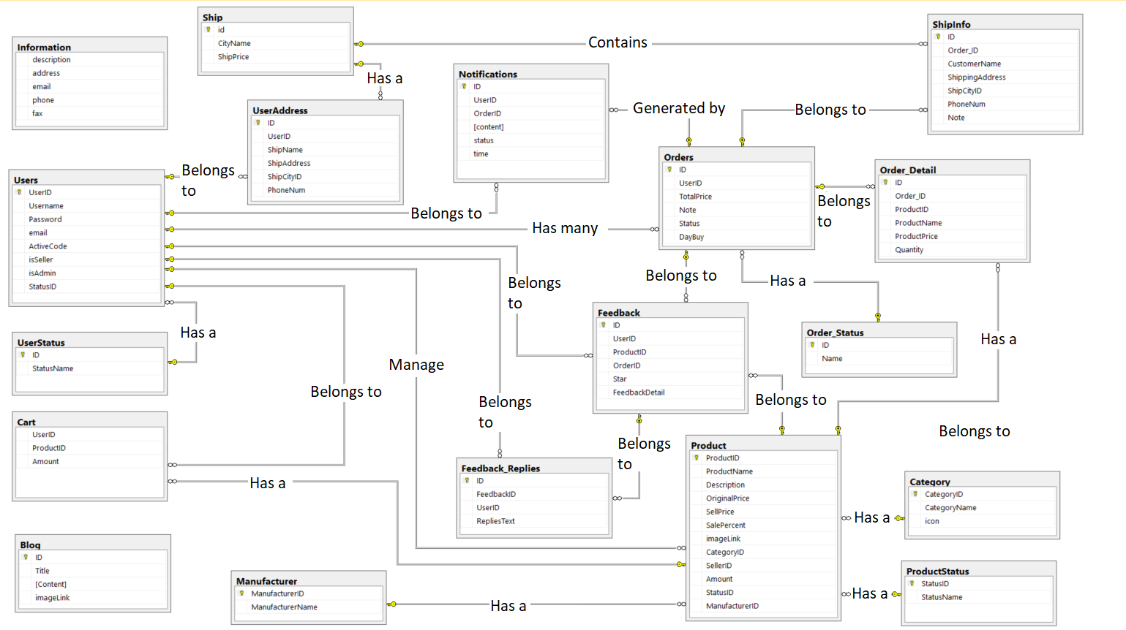

**Entities List**

|  |  |  |
| --- | --- | --- |
| **#** | **Entity** | **Description** |
| 01 | Product | Store the information of all products |
| 02 | Users | Store the information of all users (including customers, sellers and admin) |
| 03 | Cart | Store information of the Cart (a list of product) of each Customer |
| 04 | Category | Store the information of Categories of products |
| 05 | Ship | Store the price of ship for each City |
| 06 | Information | Store some information of the shop |
| 07 | User_Status | Store status value of user |
| 08 | User_Address | Store the default shipping address of user (user can change this information) |
| 09 | ShipInfo | Store the information of the order (including shipping address, shipping price, phone number of customer…) |
| 10 | Manufacturer | Store the manufacturer name of the product |
| 11 | Orders | Store the information about orders |
| 12 | Order_Detail | Store information about detailed shopping in every order. |
| 13 | Order_Status | Store the status value of the order |
| 14 | Notifications | Store all of notifications of all users (customers, sellers, admin) |
| 15 | Feedback | Store the rating of every product from the customer after buying |
| 16 | Feedback_Replies | Store the replies of admin/ moderator of the website to the customers feedbacks |
| 17 | Product_Status | Store the status value of the product |
| 18 | Blog | Store the blogs |

**3.2 Search & Filter Product**

* Function trigger: User accesses the website
* Function description:
  + Role: Guest, User
  + Purpose: Users Search for the Product they want
* Screen layout: 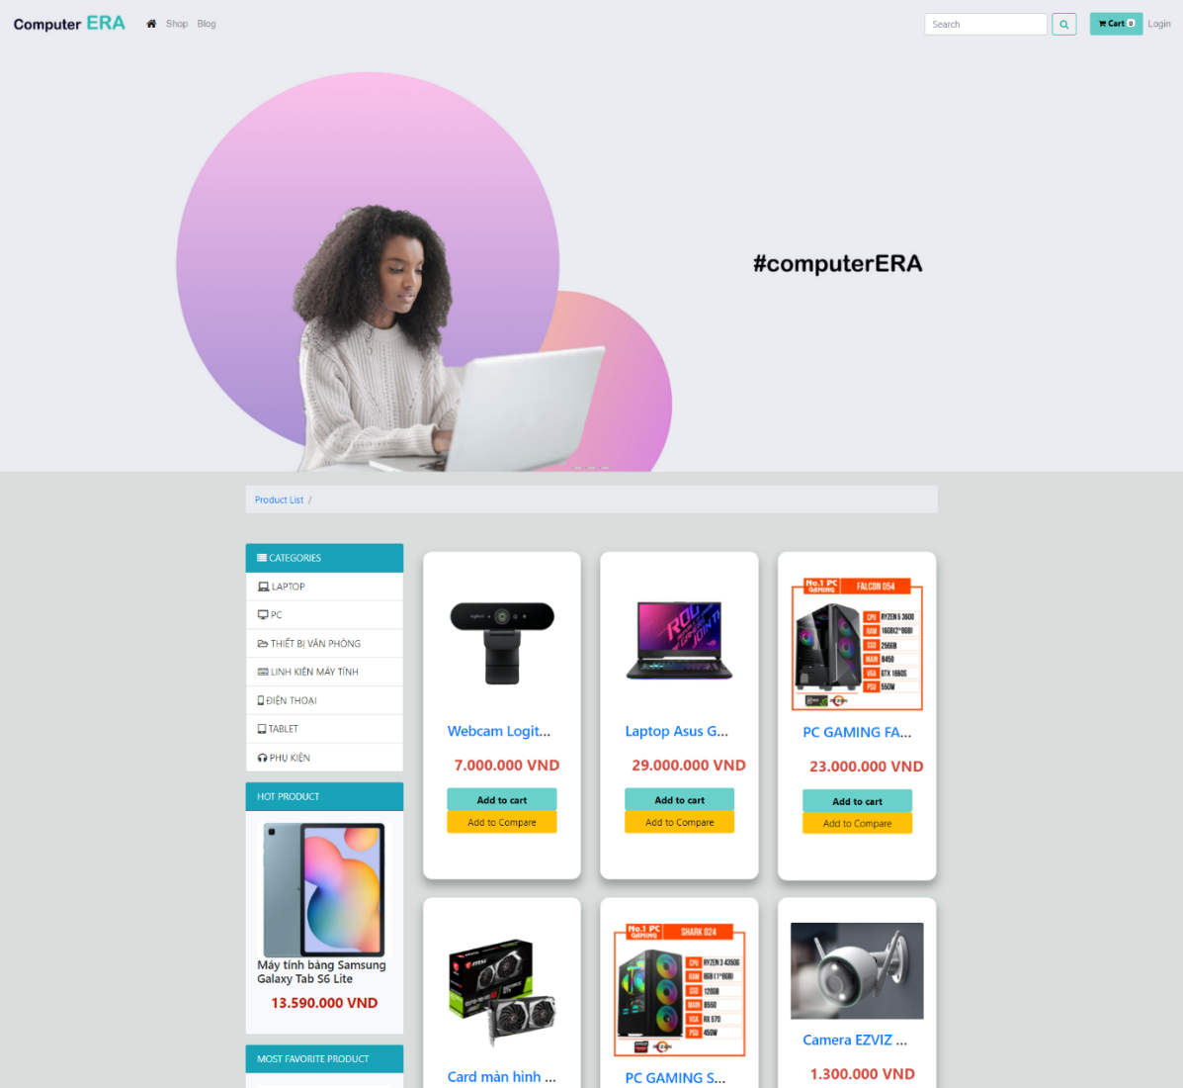

**3.3 Interact with map**

* Function trigger: User accesses the website
* Function description:
  + Role: Guest, User
  + Purpose: User can find the phisical location of the Shop
* Screen layout: 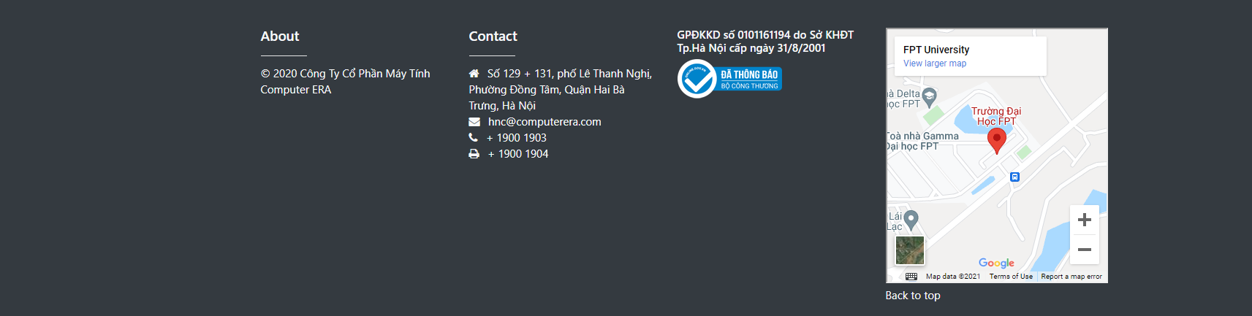
  1. **View Product Detail**
* Function trigger: User Click on a Product in Home Page
* Function description:
  + Role: Guest, User
  + Purpose: User can view all the detail information of a Product
* Screen layout:

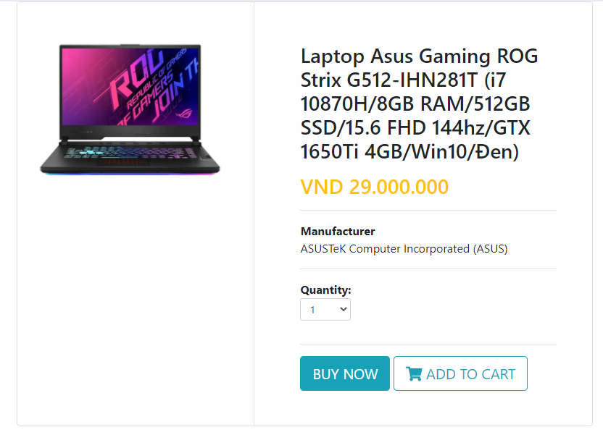

* 1. **Change Amount**
* Function trigger: User Click on “Cart” in Menu bar
* Function description:
  + Role: User
  + Purpose: User can change the amount of the Product they want to buy
* Screen layout: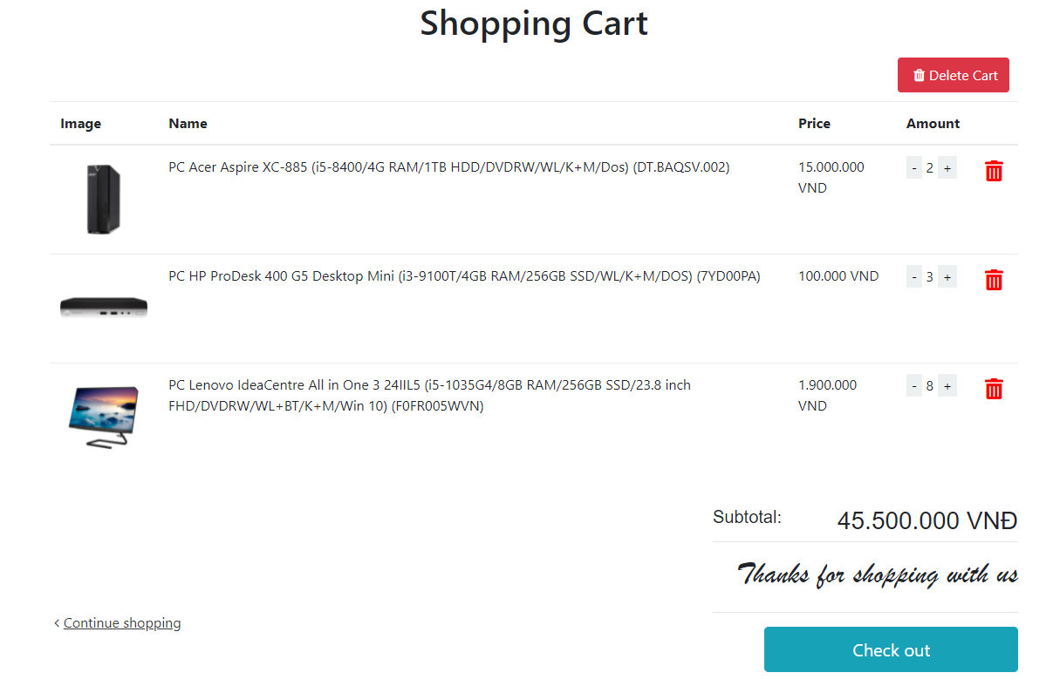
  1. **Delete Product**
* Function trigger: User Click on the Delete icon in a Product in Cart
* Function description:
  + Role: Guest
  + Purpose: User can Delete a Product from their Cart
* Screen layout:

**

* 1. **Delete Cart**
* Function trigger: User Click on “Delete Cart” button in Cart
* Function description:
  + Role: User
  + Purpose: User can delete all the Product in their Cart
* Screen layout:

**

* 1. **Login**
* Function trigger: User Click on “Login” link in the Menu bar
* Function description:
  + Role: Guest
  + Purpose: For people to log in to the system for access to more functions
* Screen layout: 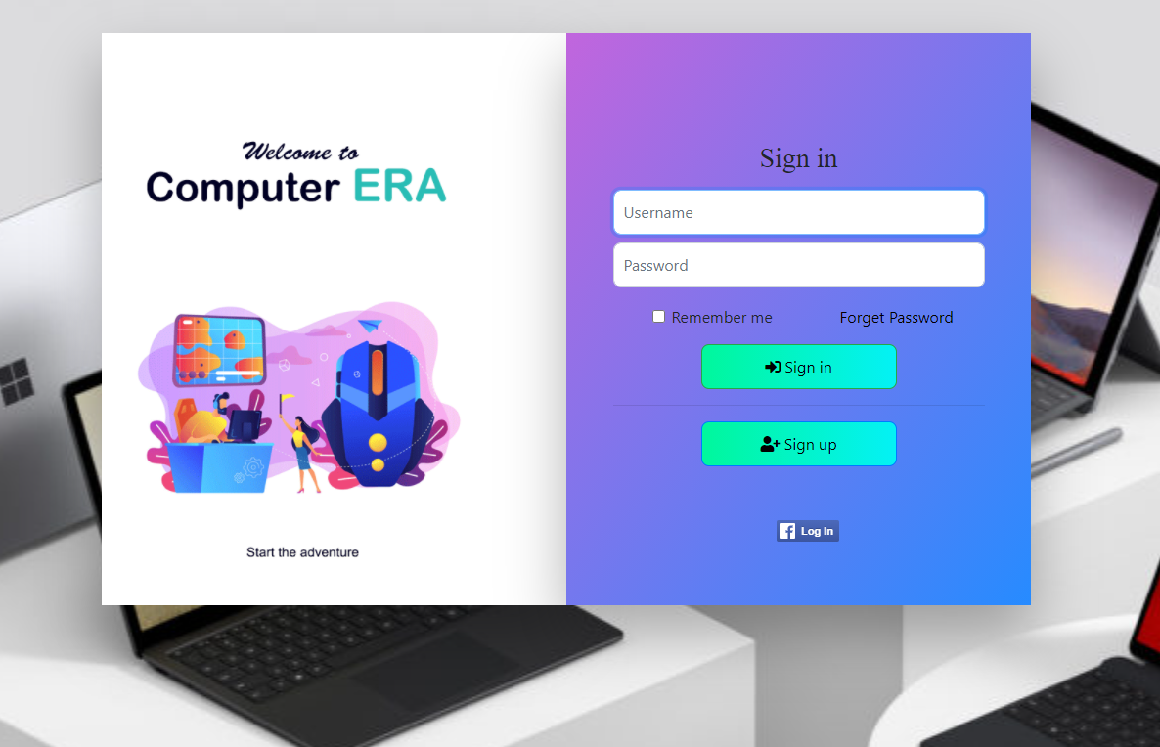
  1. **Register**
* Function trigger: Guest click “Sign up” button from Login screen.
* Function description:
  + Role: Guest.
  + Purpose: Provide a form for customer to register an account.
* Screen layout: 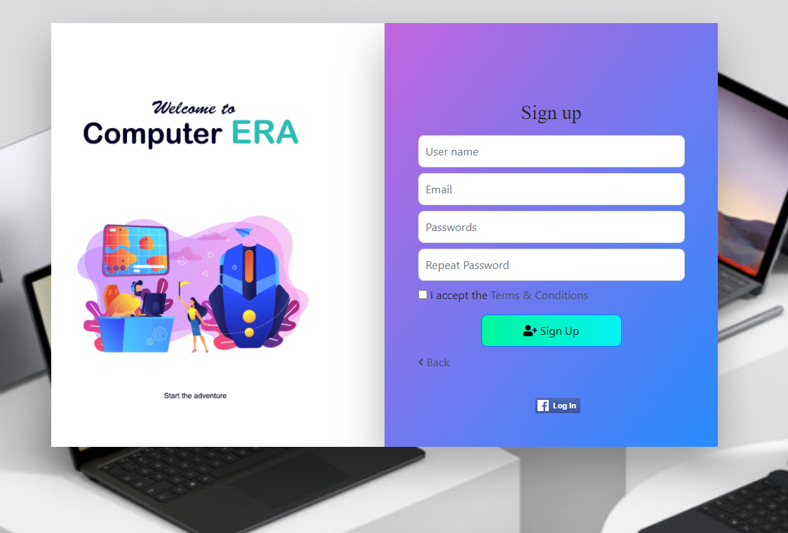
  1. **Send Code**
* Function trigger: After Guest fill the information to the form, click sign up button.
* Function description:
  + Role: Guest.
  + Purpose: Send a code to the Guest previously entered email to active account, prompt Guest to enter the code sent to the email to active the account.
* Screen Layout:

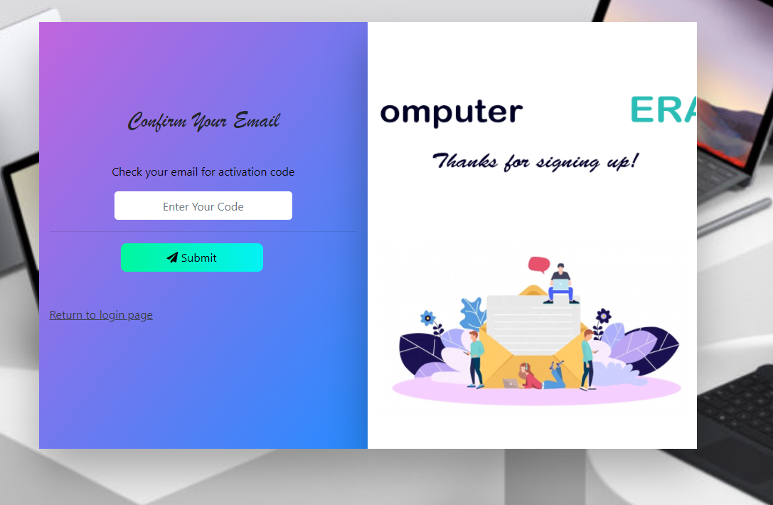

* 1. **View User List**
* Function trigger: Admin click on “Total Account” card or “Manager Account” link from Admin Dashboard.
* Function description:
  + Role: Admin.
  + Purpose: View list of all account.
* Screen layout:

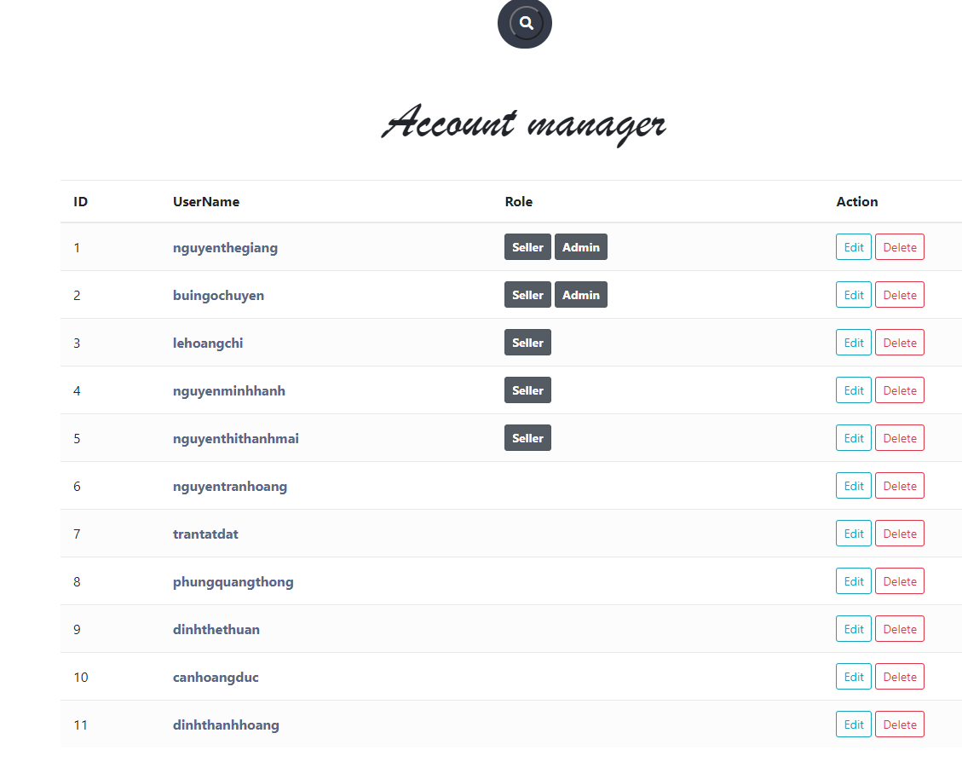

* 1. **Edit User**
* Function trigger: Admin click “Edit” button next to an entry from user list.
* Function description:
  + Role: Admin.
  + Purpose: Edit information of an account.
* Screen layout:

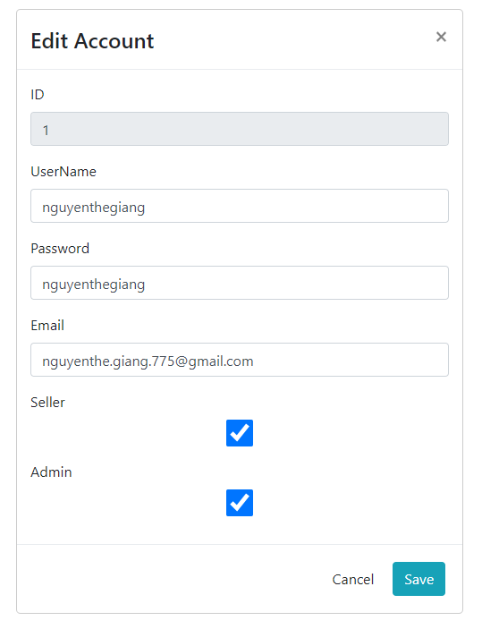

* 1. **Delete User**
* Function trigger: Admin click “Delete” button next to an entry from user list.
* Function description:
  + Role: Admin.
  + Purpose: Delete an account from the system.
* Screen layout:

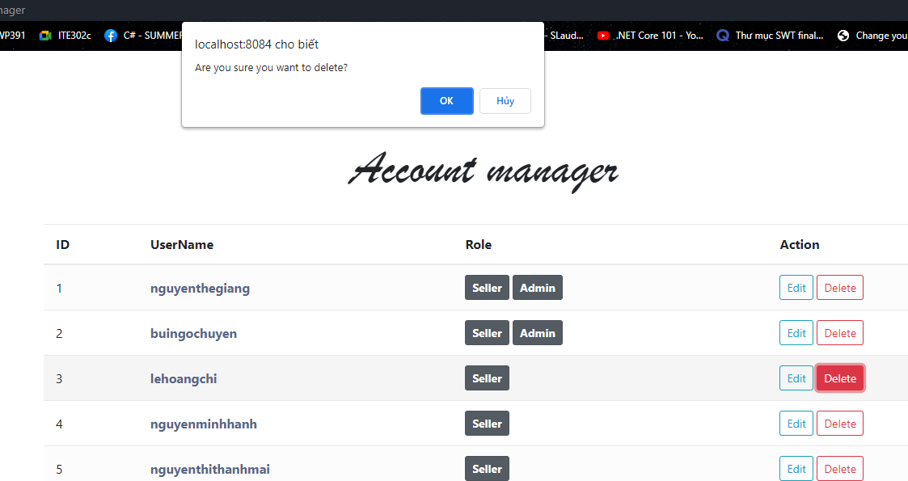

* 1. **Add Ship Information**
* Function trigger: When a customer click the checkout button from cart but the user has no default shipping address.
* Function description:
  + Role: Customer.
  + Purpose: Add a default shipping information.
* Screen layout:

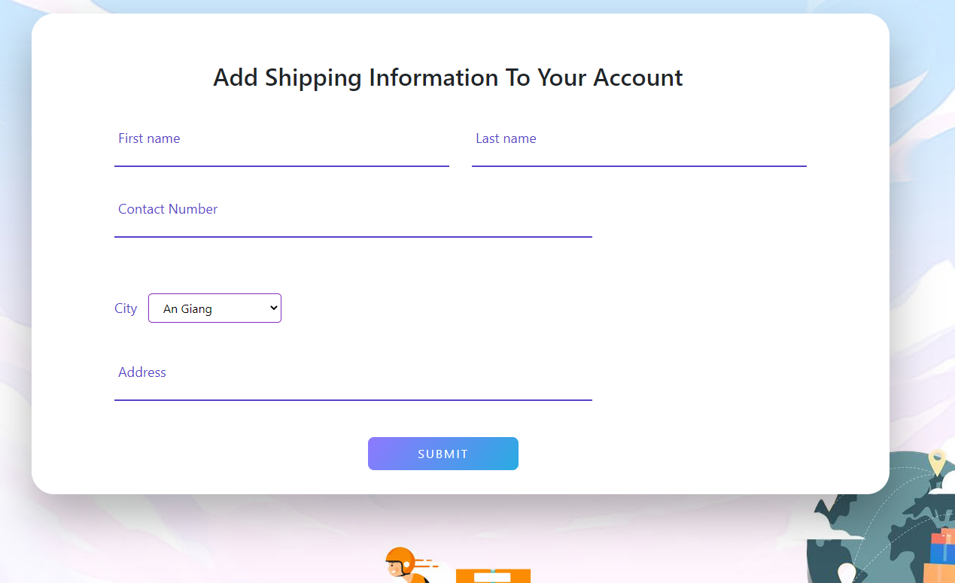

* 1. **Change Ship Information**
* Function trigger: Customer click the “Change shipping information” when he/she wants to ship the order to a different address from his/her default address.
* Function description:
  + Role: Customer.
  + Purpose: Enter a different shipping information for an order.
* Screen layout:

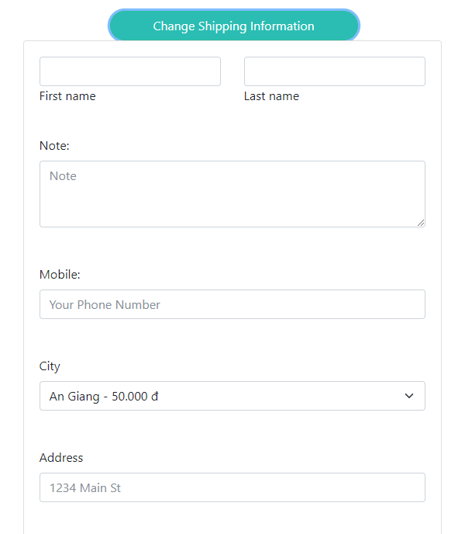

* 1. **Reset Password**
* Function trigger: Users access the website and click on Reset Password button
* Function description:
  + Role: Buyer, Seller, Admin
  + Purpose: Users can change their passwords when they forget their old one
* Screen Layout:

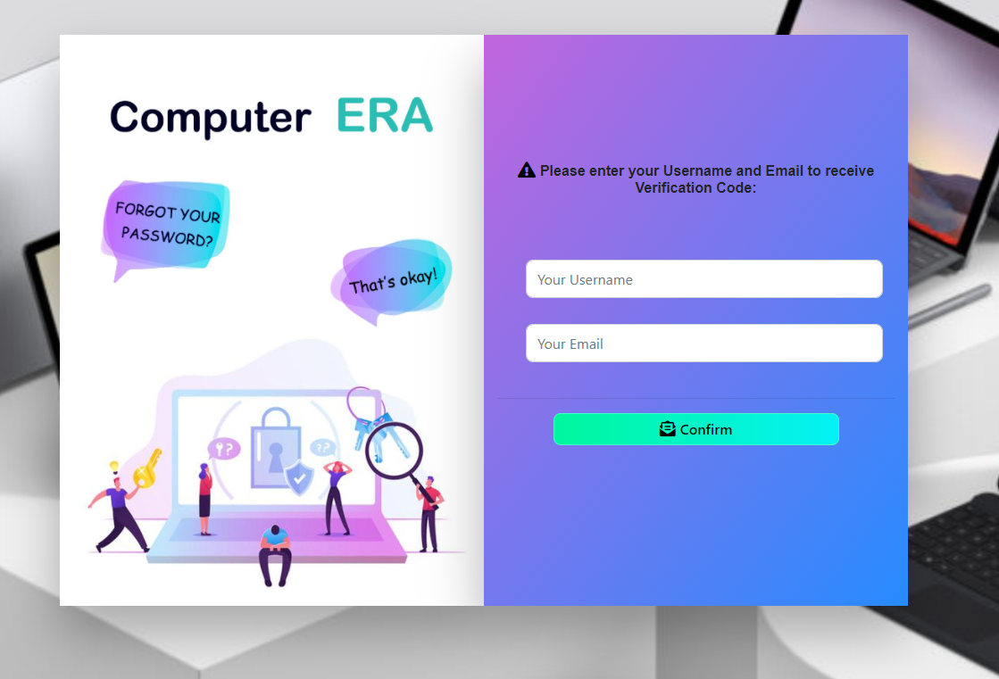

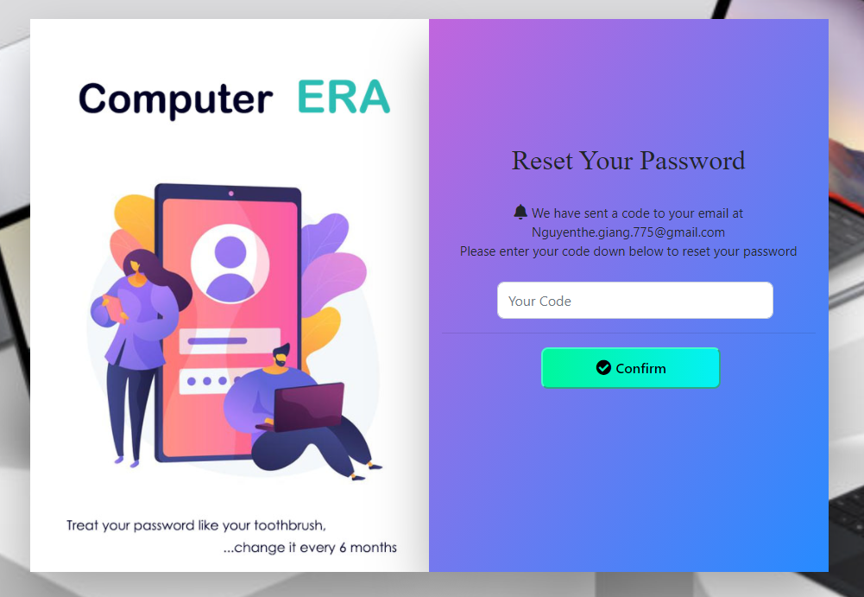

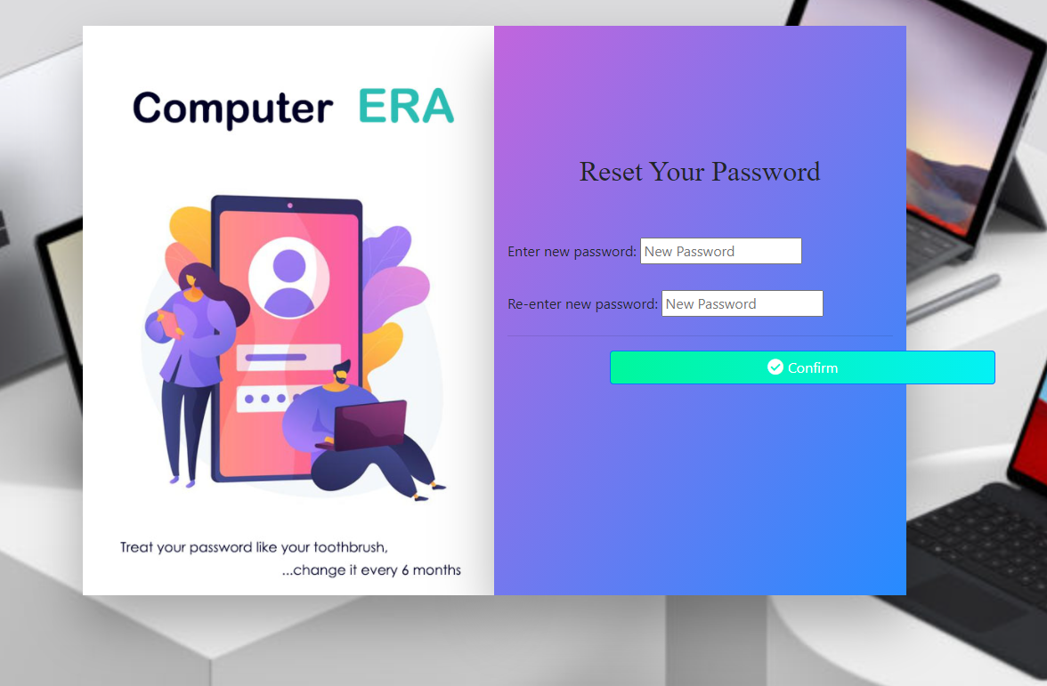

* 1. **Change Password**
* Function trigger: Users login the website and access the profile page and click on Change Password button
* Function description:
  + Role: Buyer, Seller, Admin
  + Purpose: Users can change their passwords
* Screen Layout:

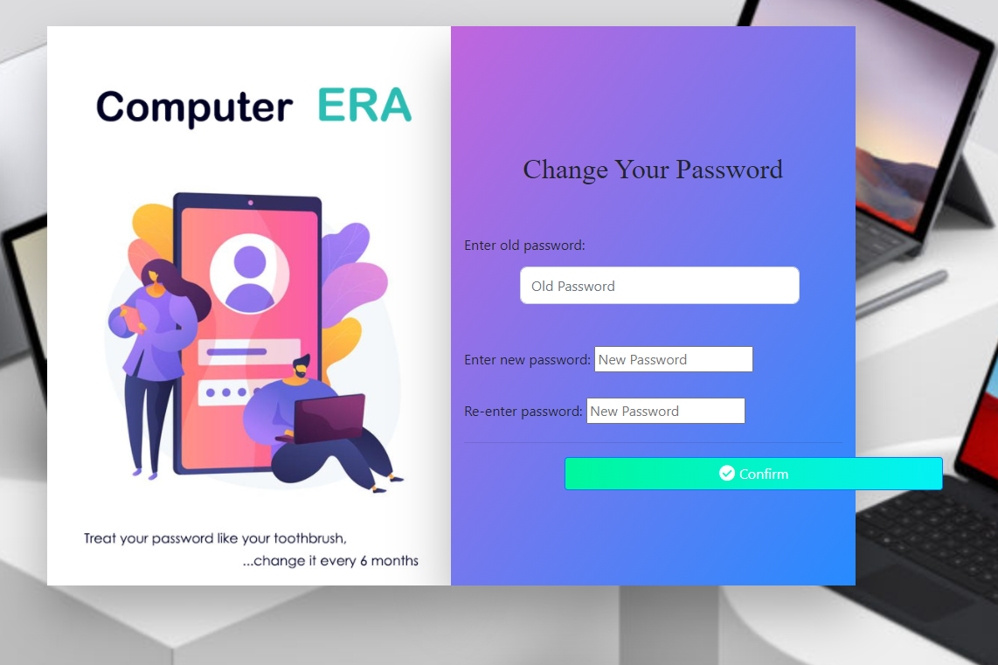

* 1. **User Profile**
* Function trigger: User log-in the website and click on the profile icon on the top-right corner
* Function description:
  + Role: Buyers, Seller, Admin
  + Purpose: Users can see their account’s detailed information
* Screen layout: 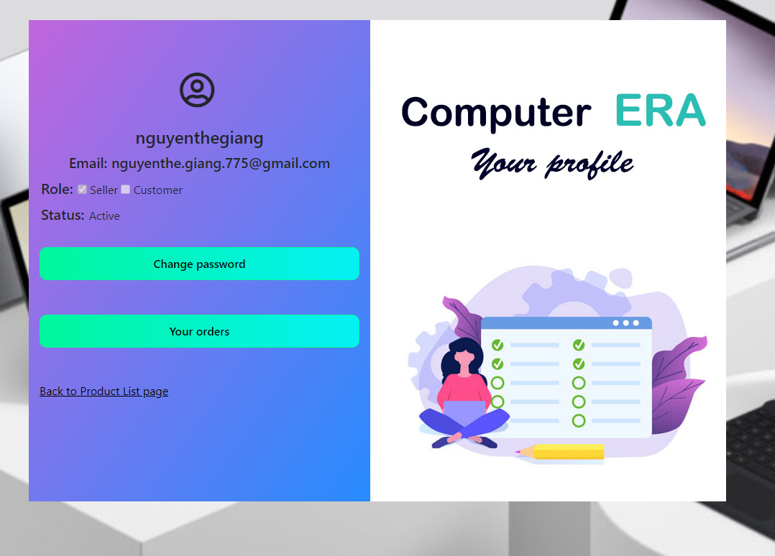
  1. **My Orders**
* Function trigger: Users log-in the website, access the profile page and click on My Orders button
* Function description:
  + Role: Buyers
  + Purpose: Users can see their shopping history
* Screen layout:

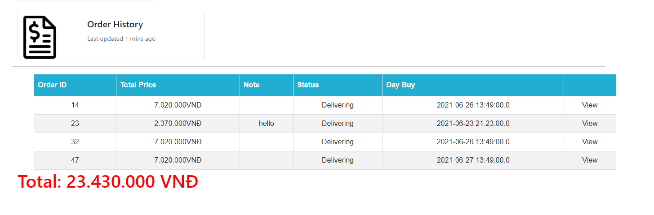

* 1. **Order Information**
* Function trigger: Users log-in to the website, access My Orders page and click View button
* Function description:
  + Role: Buyers
  + Purpose: See the order detailed information
* Screen layout:

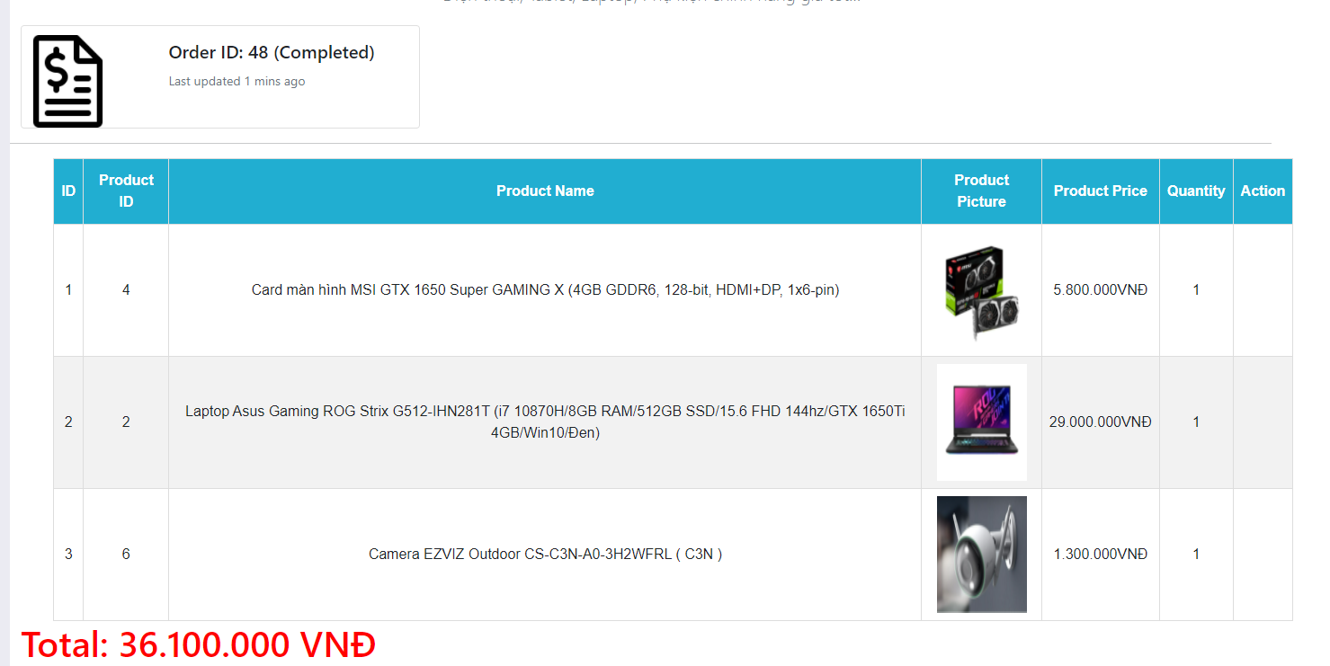

* 1. **View Product List**
* Function trigger: Users login as admin and click on Manage Product button or Product List button
* Function description:
  + Role: Admin
  + Purpose: Admin can manage the products of the website (add, delete, edit…)
* Screen layout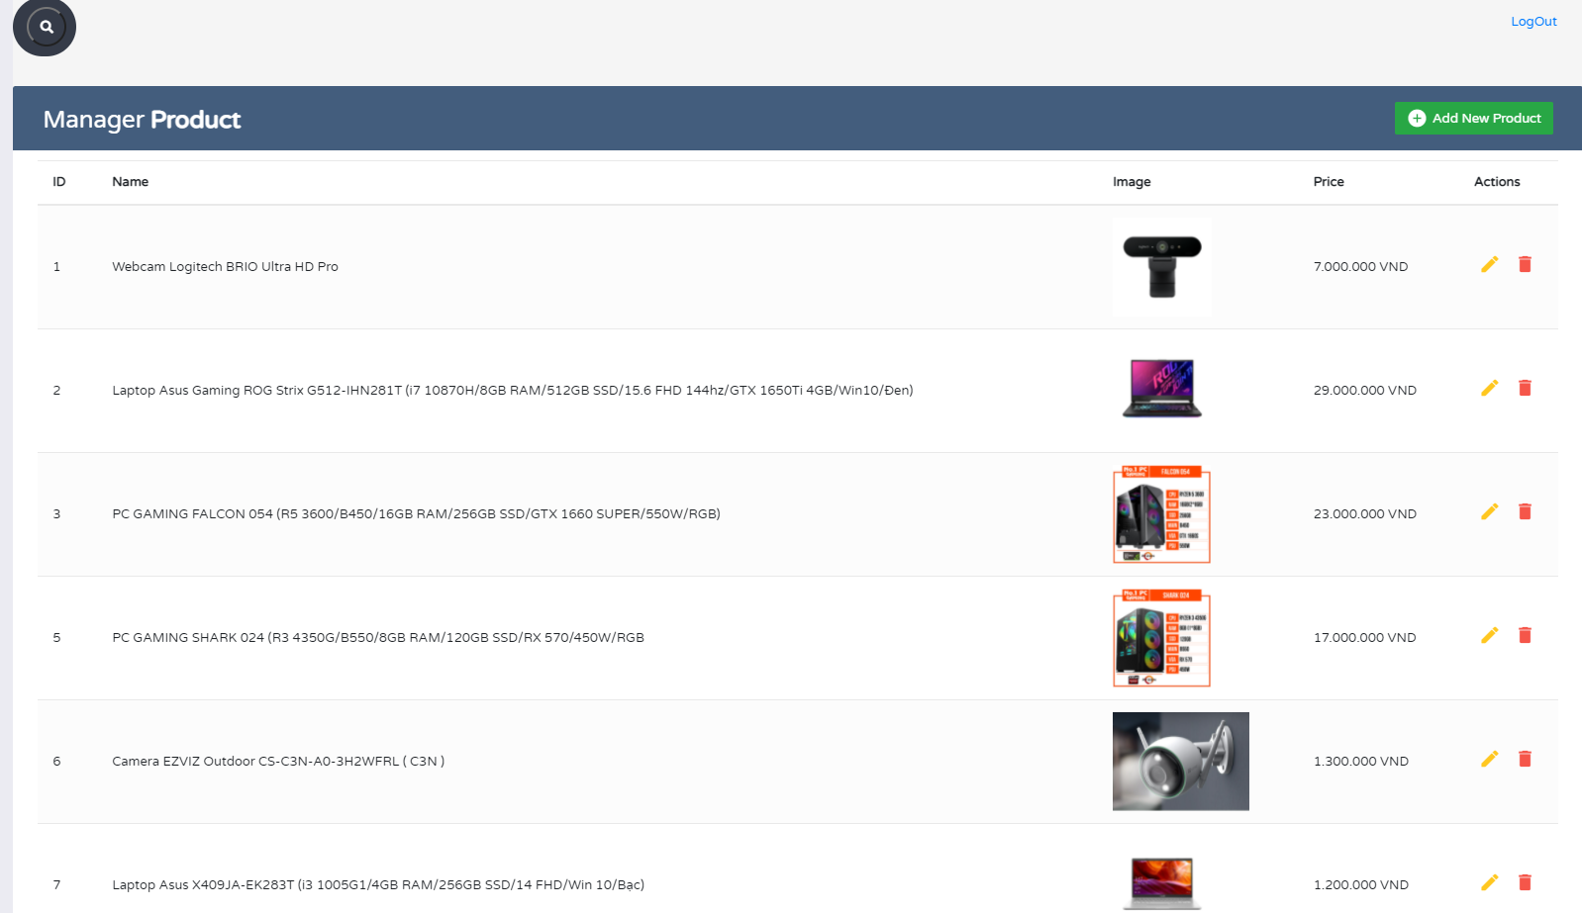
  1. **Sale Dashboard**
* Function trigger: Users login as Admin/ Seller
* Function description:
  + Role: Admin, Seller
  + Purpose: Users can view the commercial operations statistically (with charts),…
* Screen layout: 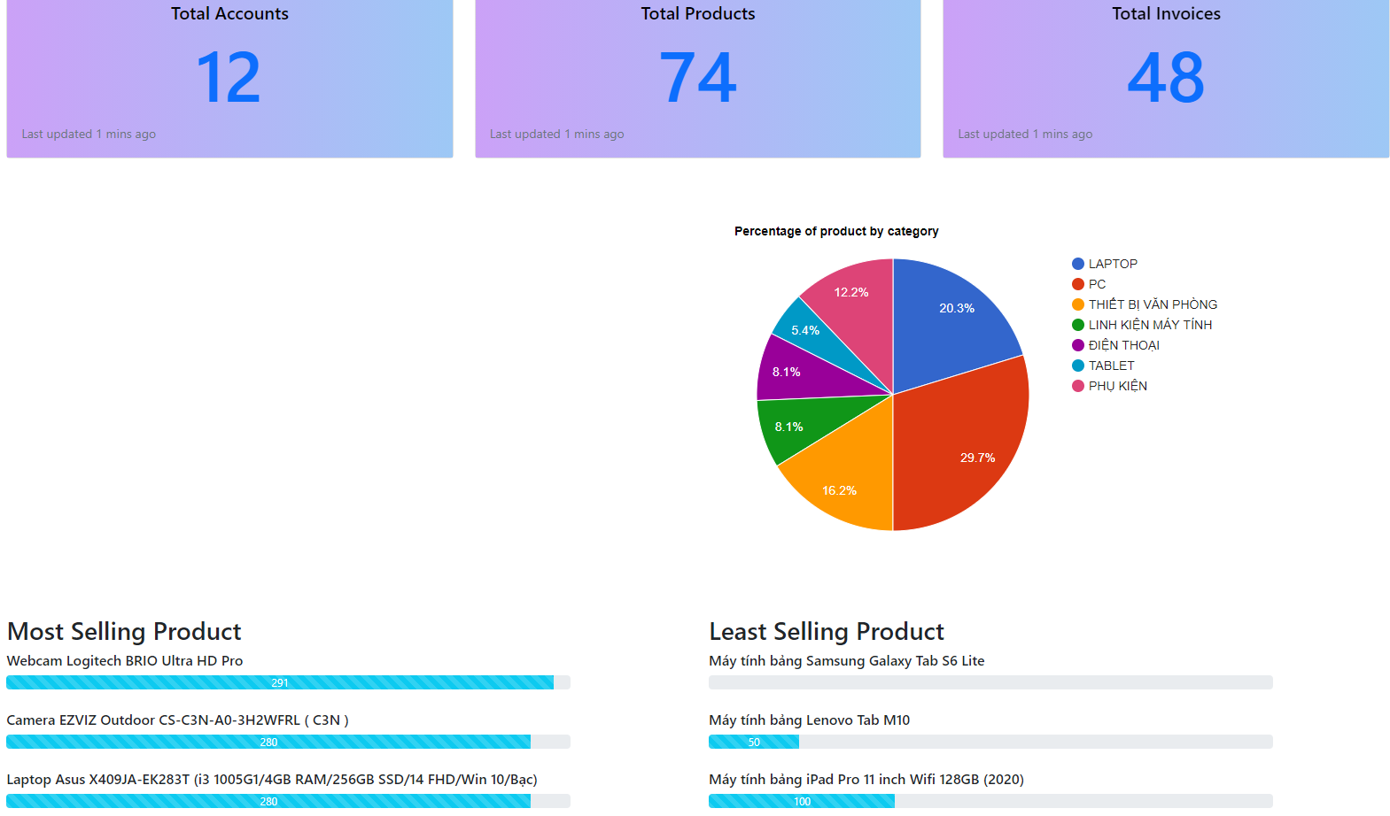
  1. **Order List**

Function trigger: Admin Login and click Total Invoices

Function description:

• Role: Admin

• Purpose: Admin views list of all of 2orders

Screen layout:

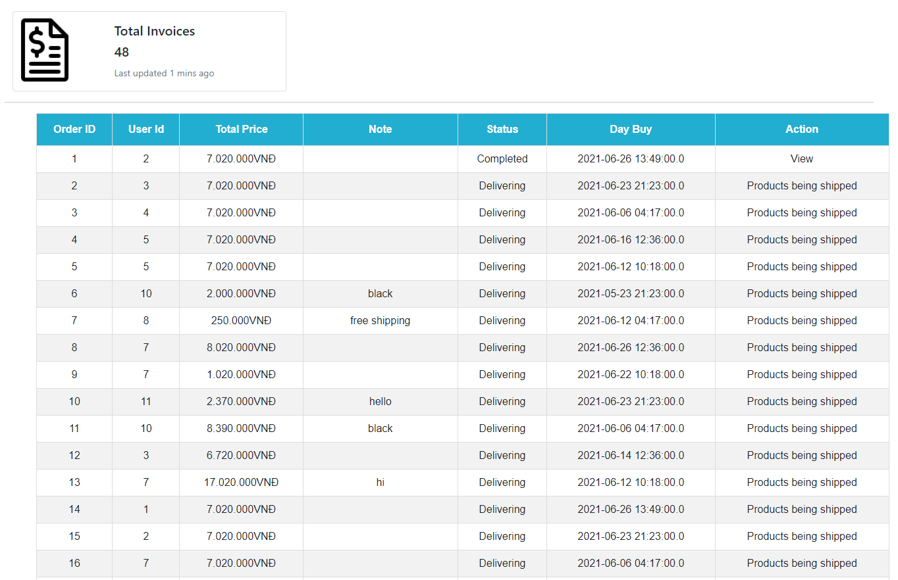

* 1. **Order Details**

Function trigger: Seller Login and click Total Invoices

Function description:

• Role: Seller

• Purpose: Seller views the detail of 1 of his orders

Screen layout:

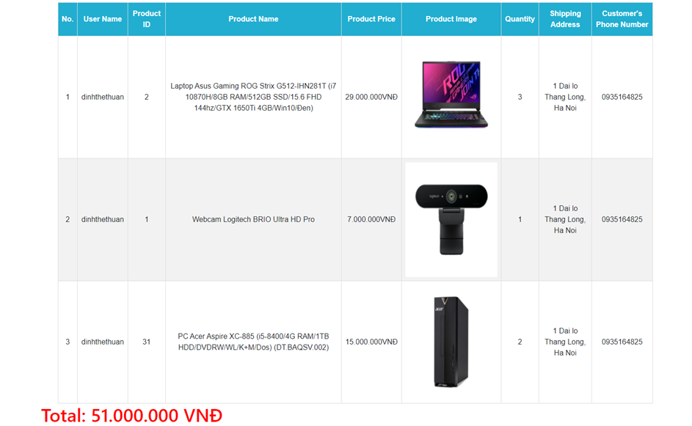

* 1. **View Feedback**

Function trigger: Customers click on the product they want to see, scroll down to see the feed back

Function description:

* Role: Guest, User
* Purpose: Customer views all the Feedbacks about a Product

Screen layout:

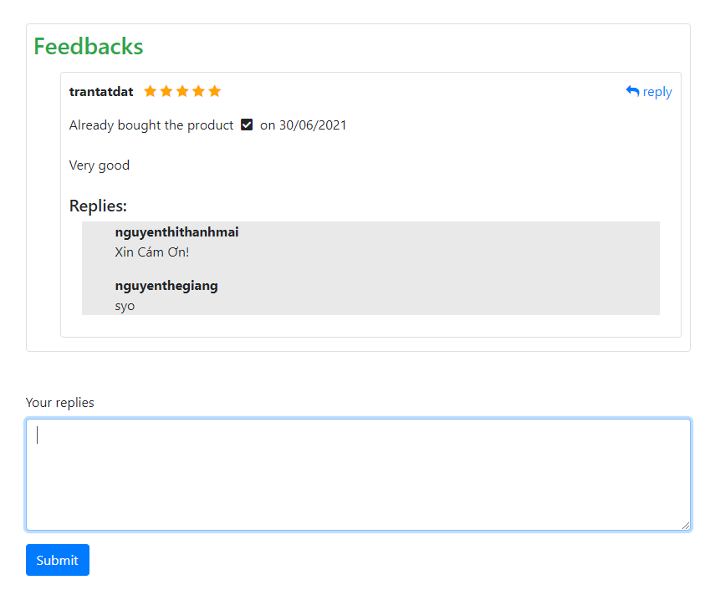

* 1. **Send Feedback**

Function trigger: When the user receives the goods, click on My order and then click on Add feed back and evaluate

Function description:

* Role: Guest, User
* Purpose: Customer writes and send a Feedback about a Product

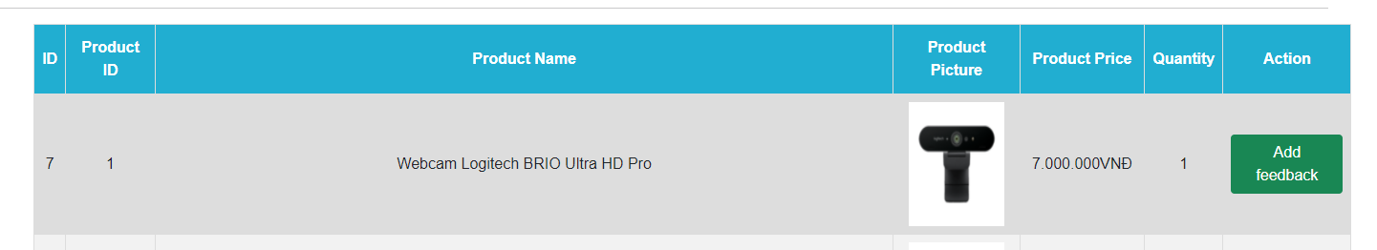Screen layout:

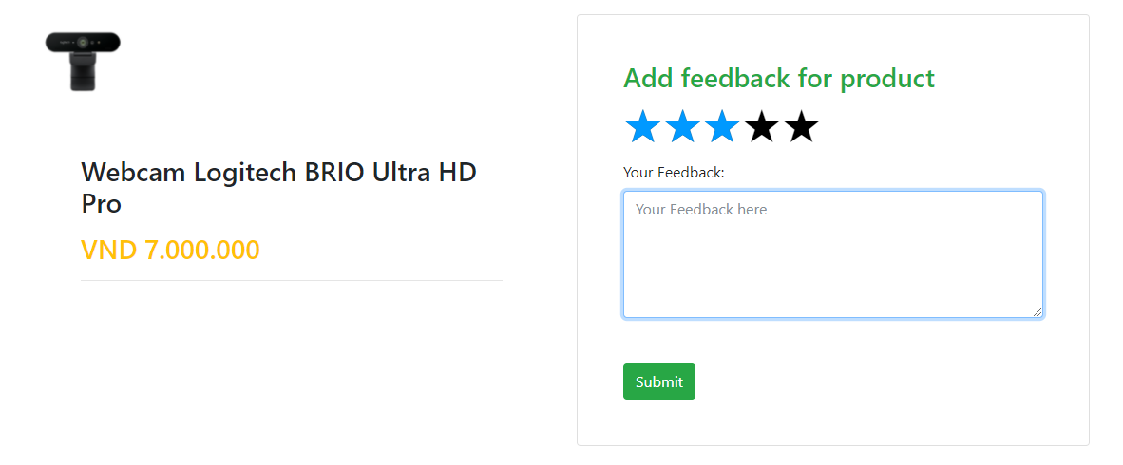

* 1. **Blogs List**

Function trigger: User Click Blog in menu bar

Function description:

* Role: Guest, User
* Purpose: Customer views the list of all Blogs

Screen layout:

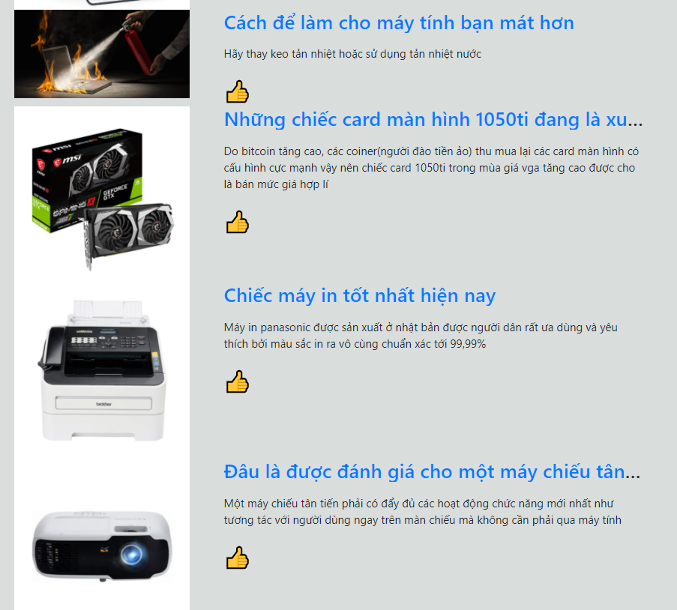

* 1. **Blog Details**

Function trigger: User Click Blog in menu bar. Next, click Blog want to see detail

Function description:

Role: Guest, User

Purpose: Customer views the Detail information of 1 Blog

Screen layout:

**

* 1. **View Notifications**
* Function trigger: User logs-in the website, clicks or mouses over on the bell
* Function description:
  + Role: User, Seller, Admin
  + Purpose: User views the list of all Notifications
* Screen layout:

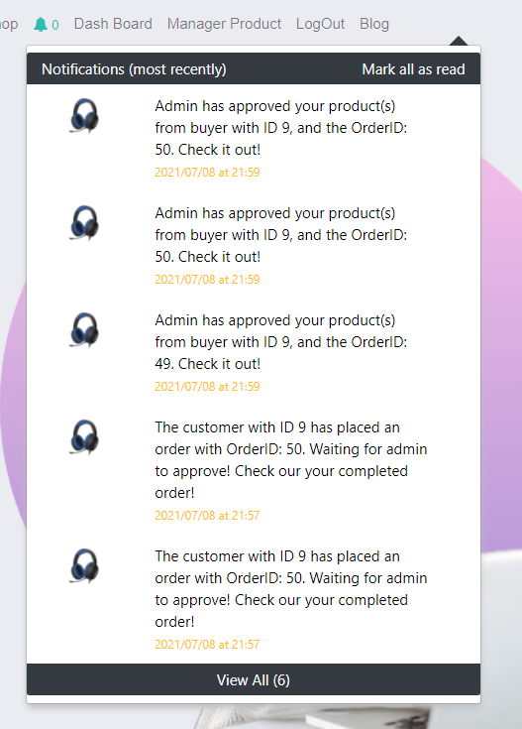

* 1. **View All Notifications**
* Function trigger: User logs-in the website, clicks on the bell and clicks on the “View all” link
* Function description:
  + Role: User, Seller, Admin
  + Purpose: User views the list of all Notifications
* 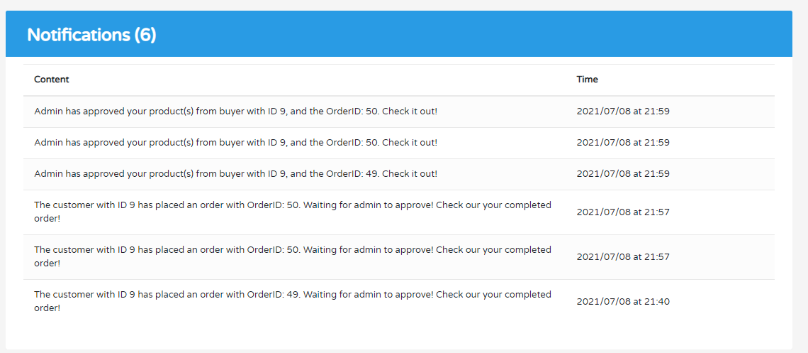Screen layout:
  1. **Mark as read**
* Function trigger: User logs-in the website, clicks on the text “Mark all as read”
* Function description:
  + Role: User, Seller, Admin
  + Purpose: User mark all the new Notification as read
* 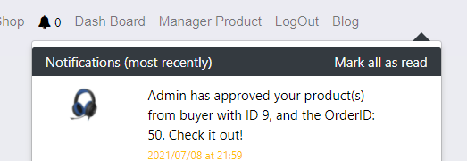Screen layout:
  1. **Search to Compare**
* Function trigger: User accesses the website, adds a product to compare and then types in the input searching box
* Function description:
  + Role: Guest, User
  + Purpose: User searches for a Product to Compare with the Current Product
* 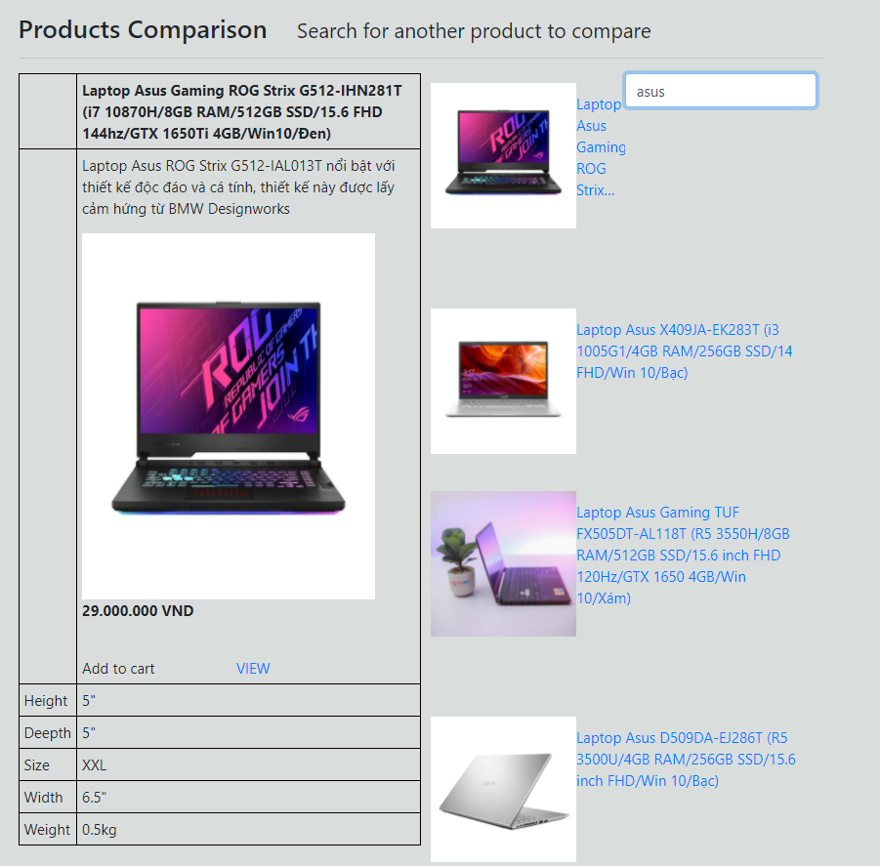Screen layout
  1. **View Comparison**
* Function trigger: User accesses the website, adds a product to compare and then types in the input searching box, chooses a product to compare
* Function description:
  + Role: Guest, User
  + Purpose: User views all the Compare information
* Screen layout: 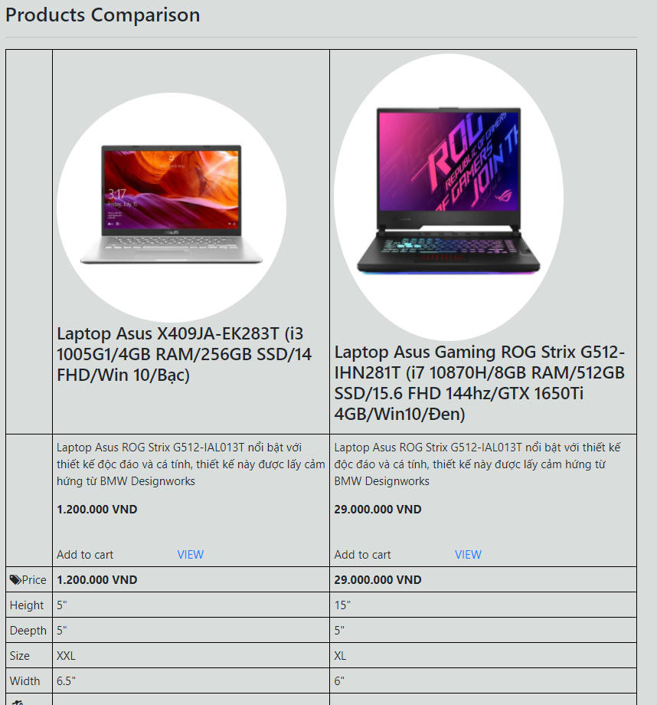
  1. **Error**
* Function trigger: User accesses the website, the website got an error
* Function description:
  + Role: Guest, User, Seller, Admin
  + Purpose: Show in case there’s an Error occurs
* Screen layout:

**

# 4. Data Requirements

## 4.1 Logical Data Model

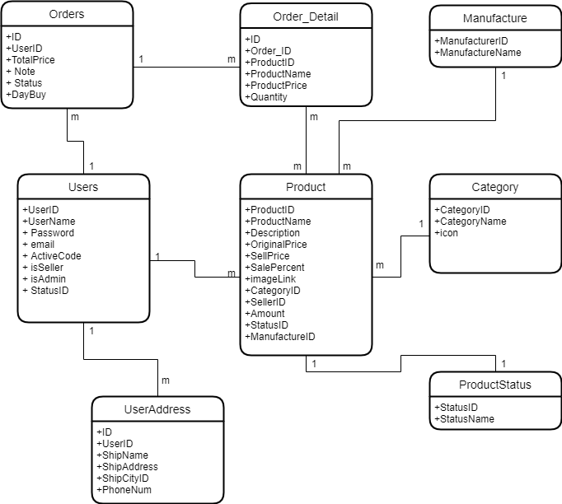

Figure 1. Partial data model for release 2.0 of the Electronic Shop System.

## 4.2 Data Dictionary

|  |  |  |  |  |
| --- | --- | --- | --- | --- |
| Data Element | Description | Composition or Data Type | Length | Values |
| Product | Information about product In Electronic Shop | +ProductID +ProductName +Description +OriginalPrice +SellPrice +SalePercent +imageLink +CategoryID +SellerID +Amount +StatusID +ManufactureID |  |  |
| ProductID | Distinguish products by ID | int | 255 | Not null |
| ProductName | Name of the product | Nvarchar | 1000 |  |
| Description | Description of product information | Nvarchar | 2000 |  |
| OriginalPrice | Initial import price | int | 255 |  |
| SellPrice | Selling price to customers | Int | 255 |  |
| SalePercent | Product discount by percentage | Int | 255 | *% |
| imageLink | Link to product image | Nvarchar | 1000 |  |
| CategoryID | Classify product by CategoryID In table Category | Int | 255 |  |
| SellerID | Seller of this product | Int | 255 |  |
| Amount | Number of products in stock | Int | 255 |  |
| StatusID | Condition of the product | Int | 255 | Available and StopBusiness |
| ManufactureID | supplier for this product | Int | 255 |  |
| User | Provide user information | +UserID +UserName + Password + email + ActiveCode + isSeller + isAdmin + StatusID |  |  |
| UserID | Distinguish user by ID | Int | 255 | Not Null |
| UserName | Website login name | Nvarchar | 500 |  |
| Password | Website login password | Nvarchar | 1000 |  |
| email | Email associated with user's account | Nvarchar | 1000 |  |
| ActiveCode | Verification code for account registration | Nvarchar | 11 |  |
| isAdmin | Distinguish user is Admin or not Admin | Int | 1 | 0 and 1 |
| StatusID | show the status of the account | Int | 10 | |  | | --- | | Active | | Locked | | FB Login | | Unverified | |
| isSeller | Distinguish whether the user is a Seller or not Seller | Int | 1 | 0 and 1 |
| Order |  | +ID +UserID +TotalPrice + Note + Status +DayBuy |  |  |
| ID | Distinguish order by ID | Int | 255 | Not null |
| UserID | To know whose order this is | Int | 255 |  |
| TotalPrice | price to be paid by the customer | Float | 32 bit |  |
| Note | Notes that have been agreed with the customer | Nvarchar | 2000 |  |
| Status | Is the status of the product confirmed? | int | 25 | |  | | --- | | Waiting for Confirmation | | Packaging | | Delivering | | Canceled | | Completed | |
| DayBuy | Show purchase date | DayBuy | Datetime | YYYY-MM-DD |
| UserAddress |  | +ID +UserID +ShipName +ShipAddress +ShipCityID + PhoneNum |  |  |
| ID | Distinguish user address by ID | Int | 255 | Not null |
| UserID | To know who this address belongs to | Int | 255 |  |
| ShipName | Customer's name | Nvarchar | 500 |  |
| ShipAddress | Customer's address for delivery | Nvarchar | 1000 |  |
| ShipCityID | Tell where the customer is in 63 provinces and cities to distinguish the delivery fee | int | 2 | from 1 to 63 corresponding to 63 provinces of Vietnam in order |
| PhoneNum | Customer phone number to contact | Varchar | 20 |  |
| Order_Detail | Detailed information in customer's order form | +ID +Order_ID +ProductID +ProductName +ProductPrice +Quantity |  |  |
| ID | Distinguish order_detail by ID | Int | 255 | Not null |
| Order_ID | See which invoice belongs to | Int | 255 |  |
| ProductID | See what products are available | Int | 255 |  |
| ProductName | Purchased product name | Nvarchar | 1000 |  |
| ProductPrice | Price of the product | Int | 255 |  |
| Quantity | Quantity of products purchased | Int | 255 |  |
| Manufacture | Manufacturers make algae products | +ManufacturerID +ManufactureName |  |  |
| ManufacturerID | Distinguish address manufacturer by ID | Int | 255 | Not null |
| ManufactureName | The name of the manufacturer who made the product | Nvarchar | 1000 |  |
| Category | Types of products available in the Electronic Shop | +CategoryID +CategoryName +icon |  |  |
| CategoryID | Distinguish category by ID | Int | 255 | Not null |
| CategoryName | Name of product type | Nvarchar | 1000 |  |
| icon | Icon for that product type | Nvarchar | 1000 | Image |
| ProductStatus | Status of that product | +StatusID +StatusName |  |  |
| StatusID | Distinguish product status by ID | Int | 1 | 1 and 2 |
| StatusName | Condition of the goods | Nvarchar | 1000 | Available and StopBusiness |

# 4.3 Reports

### 4.3.1 Ordered Product History Report

|  |  |
| --- | --- |
| Report ID: | 1 |
| Report Title: | Ordered Product History |
| Report Purpose: | Customer wants to see a list of all product that he had previously ordered from the Electronic Shop over a specified time period up to six months prior to the current date, so he can reorder a particular product he liked.. |
| Priority: | Medium |
| Report Users: | Customer |
| Data Sources: | Database of previously placed product orders |
| Frequency and Disposition; | Report is generated on demand by a Customer. Data in the report is static. Report is displayed on user's web browser screen on a computer, tablet, or smartphone. It can be printed if the display device permits printing. |
| Latency: | Complete report must be displayed to customer within 4 seconds after it is requested. |
| Visual Layout: | Landscape mode |
| Header and Footer: | Report header shall contain the report title, Customer's name, and date range specified. If printed, report footer shall show the page number. |
| Report Body: | Fields shown and column headings:   * Order ID * Order Date * Ordered Detail * Product Items ordered (list all product items in the product order, their quantity, and their prices) * Total Price * Sale Percent * Delivery Charge * Total Price (sum of product item prices, sale percent, and delivery charge)   Selection Criteria: date range specified by Customer, inclusive of end points  Sort Criteria: reverse chronological order |
| End-of-Report Indicator: | None |
| Interactivity: | Customers can see more detailed information of product ingredients |
| Security Access Restrictions: | A Customer may retrieve only his own meal order history |

## 4.4 Data Integrity, Retention, and Disposal

DI-1: Electric Shop system will store customer orders so that when customers want to see what they bought last time.

DI-2: All products purchased from Electronic Shop will be covered by a 36-month warranty. Customers will be guaranteed warranty on the invoice that has been paid at the time of purchase

# 5. External Interface Requirements

## 5.1 User Interfaces

UI-1: The Electronic Shop Ordering System screen displays shall conform to the User Interface Design and User Experience Design

UI-2: The website is designed with the feature of using ajax technology a lot to provide a smooth user experience without having to reload the website many times..

## 5.2 Software Interfaces

SI-1: Electronic Shop Account Checking system

SI-1.1: Upload existing user data in the system through a programming interface

SI-1.2: The system automatically checks what state the account is in in the UserStatus

SI-1.3: There will be 4 states including Active Locked FB Login Unverified. If the account belongs to Active and FB login, you will be able to purchase. If you belong to Locked, you will not be able to log in and have to create a new account, and if you belong to Unverified, you must go to gmail to verify your account.

SI-2: Electronic Shop Inventory System

SI-2.1: Electronic System shall transmit the quantities of product items ordered to the Electronic Shop Inventory System through a programmatic interface.

SI-2.2: Electronic System shall poll the Electronic Shop Inventory System to determine whether a requested product item is available.

SI-2.3: The Electronic system will display the quantity left in stock for the buyer. If there is no stock in stock, the user will not be able to place an order for this product.

## 5.3 Hardware Interfaces

No hardware interfaces have been identified.

## 5.4 Communications Interfaces

CI-1: Electronic Shop shall send an email or call phone number (based on user account settings) to the Customer to report any problems with the product order or delivery.

# Nonfunctional Requirements

## Performance Requirements

PE-1: The system shall be able to provide services normally to around 1000 concurrent users during the peak usage time window of 8:00 A.M. to 10:00 P.M. local time, with an estimated average session duration of 30 minutes.

PE-2: The web pages shall fully load in an average of 4 seconds in normal condition, 7 seconds in peak usage condition from the time the user requests the page over a 20Mbps or faster Internet connection.

PE-3: The system’s confirmation pages shall be display to users within an average of 9 seconds and a maximum of 15 seconds after the user submits information to the system.

## Security

SE-1: The website shall use standard Web security protocols when transferring any private information regarding a Guest, Customer, or Seller.

SE-2: Users shall be required to log on to the Electronic Shop website for all operations except viewing home page, blog, product list and viewing a specific product.

SE-3: Only the Admin shall be permitted to confirm an order, only the Customer shall be permitted to confirm an order has been delivered.

SE-4: The system shall permit Customer to view only orders that they placed and give a feedback on each products in those orders.

## Availability

AVL-1: The Electronic Shop website shall be available at least 98% of the time between 5:00 A.M. and midnight local time and at least 90% of the time between midnight and 5:00 A.M. local time, excluding scheduled maintenance windows.

# Other Requirements

OTR-1: If the connection between the user and the Electronic Shop is broken prior to a new order being either confirmed or terminated, the Electronic Shop shall enable the user to recover an incomplete order and continue working on it.

OTR-2: All confirmation code and order information will be send via user’s email.

OTR-3: The users email and user name cannot be changed.

# Appendix A: Analysis models

## Use Case Diagram

## Context Diagram